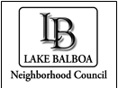
Lake Balboa Neighborhood Council
www.LakeBalboaNC.org
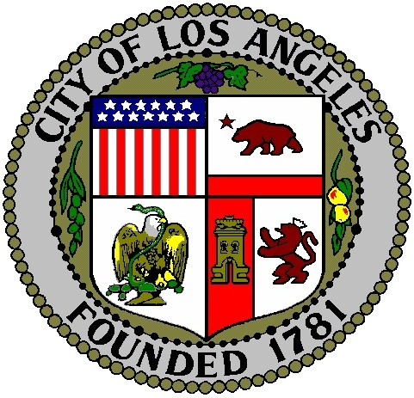

Application for Consideration of Appointment
To the Lake Balboa Neighborhood Council

Please Print

FIRST NAME ____________ MIDDLE _____________LAST NAME____________________

ADDRESS______________________________________________________ZIP _______

OCCUPATION _________________________________________________________________________

EMAIL ADDRESS __________________________PHONE NUMBER (_____) ____________

Neighborhood Council membership is open to all Stakeholders. “Stakeholders” shall be defined as those who live, work, or own property in the neighborhood and also to those who declare a stake in the neighborhood as a community interest stakeholder, defined as a person who affirms a substantial and ongoing participation within the Neighborhood Council’s boundaries and who may be in a community organization such as, but not limited to, educational, non-profit and/or religious organizations.
Boundaries can be found on our website www.lakebalboanc.org under “about” and then “boundaries”.

Stakeholder Qualification (please select all that apply from the items below)

I belong to the Lake Balboa Neighborhood Council because:

[ ] I am a resident within the boundaries of the Neighborhood Council (NC) and live at:
❑ See address above
- Street address: ____________________________________________Zip______

[ ] I am the owner, operator, or work at a business located within the NC boundaries:
- Name of Business or Place of Work: ______________________________________
- Business Address: ________________________________________Zip_______

[ ] I own real property in the NC:
- Property Address: ___________________________________________Zip_______

[ ] I have a vested interest in the NC based on the following ongoing significant and active involvement in the community.
- Name of organization__________________________________________________

[ ] Other:______________________________________________________________

- Address_______________________________________________ Zip________

Page 1 of 2

Please answer the following questions:

- How did you hear about Lake Balboa NC? ___________________________________________________________________

- How often have you attended a Lake Balboa NC meeting?
___________________________________________________________________

- Why do you wish to participate on the Lake Balboa NC?
___________________________________________________________________

___________________________________________________________________

- What areas of community service particularly interest you?
___________________________________________________________________

___________________________________________________________________

- Are you a member of any lobbying group? [ ] Yes [ ] No

- Do you hold any political office? [ ] Yes [ ] No

- Are you a City of Los Angeles Employee [ ] Yes [ ] No

If appointed to the Board, I am aware that in addition to the monthly NC board meeting on the first Wednesday of the month (except Jan & Jul), there are monthly committee meetings and various community outreach events scheduled during the year and I will participate in as many of these activities as I am able.

The information provided on this application is true and correct to the best of my knowledge.

____________________________ _______________________________ __________
Print Name Signature Date

Completed forms are to be emailed to LindaG@lakebalboanc.org
or mail to: Lake Balboa Neighborhood Council at P.O.Box 7720 Lake Balboa, CA 91409

Page 2 of 2

Lake Balboa Neighborhood Council: P.O. Box 7720, Lake Balboa, CA 91409 Voice-Mail 818-779-9026

